Intensive Pronouns

🔹 What Are Intensive Pronouns?
# Source: AI Source: Provided by: [Data Path: Persons Table -> ID Column: 1, Name_En Column: Motasem Essam] -> From: [Chatgpt (GPT-4-turbo)] on [7/27/2025]
Intensive pronouns (also called emphatic pronouns) are used to emphasize the subject of the sentence.
They have the same form as reflexive pronouns but serve a different purpose.
📌 They are not necessary to the meaning of the sentence — you can remove them, and the sentence will still make sense.

✅ List of Intensive Pronouns
# Source: AI Source: Provided by: [Data Path: Persons Table -> ID Column: 1, Name_En Column: Motasem Essam] -> From: [Chatgpt (GPT-4-turbo)] on [7/27/2025]
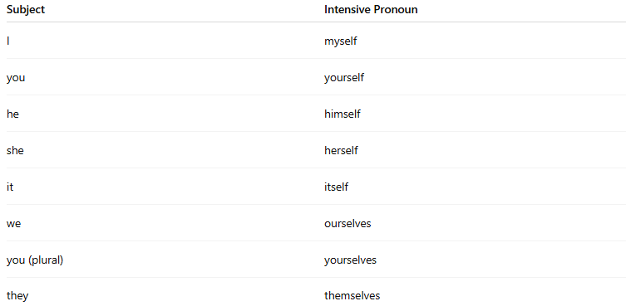
Subject | Intensive Pronoun
I | myself
you | yourself
he | himself
she | herself
it | itself
we | ourselves
you (plural) | yourselves
they | themselves

📚 Examples in Sentences
# Source: AI Source: Provided by: [Data Path: Persons Table -> ID Column: 1, Name_En Column: Motasem Essam] -> From: [Chatgpt (GPT-4-turbo)] on [7/27/2025]
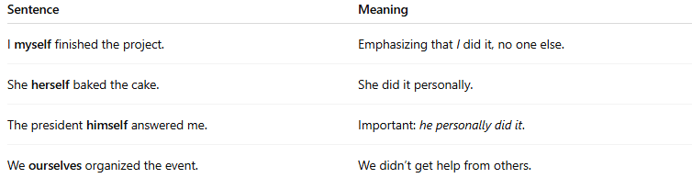
Sentence | Meaning
I myself finished the project. | Emphasizing that I did it, no one else.
She herself baked the cake. | She did it personally.
The president himself answered me. | Important: he personally did it.
We ourselves organized the event. | We didn’t get help from others.

🧠 Intensive vs Reflexive
# Source: AI Source: Provided by: [Data Path: Persons Table -> ID Column: 1, Name_En Column: Motasem Essam] -> From: [Chatgpt (GPT-4-turbo)] on [7/27/2025]
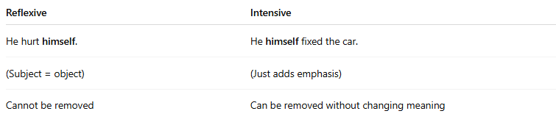
Reflexive | Intensive
He hurt himself. | He himself fixed the car.
(Subject = object) | (Just adds emphasis)
Cannot be removed | Can be removed without changing meaning

🔍 Quick Test
# Source: AI Source: Provided by: [Data Path: Persons Table -> ID Column: 1, Name_En Column: Motasem Essam] -> From: [Chatgpt (GPT-4-turbo)] on [7/27/2025]
Which is intensive, and which is reflexive?
- I taught myself to swim.
- I myself will talk to the teacher.
➡️ Answer:
1 = Reflexive
2 = Intensive

